EMBEDDED FIRE DETECTION AND ALARM

NOTIFICATION SYSTEM

TEAM MEMBERS :

* MOHAMED ASHAAN S
* SANTHOSHKUMAR S
* RAGUL E
* PRADEEBAN S

Aim:

To design a simple fire detection and alarm system using ESP32 with a flame sensor, smoke sensor, buzzer, and LEDs.

Tools required:

* ESP32
* Flame Sensor
* MQ-2 Smoke sensor
* Buzzer
* LED

1. ESP32

* The ESP-32 is a powerful, low-cost microcontroller with integrated WiFi and Bluetooth. (240MHz), Dual-core 32-bit LX6 processor.

2. Flame Sensor

* An IR-based flame sensor detects the infrared light emitted by flames in the wavelength 760 - 1100 nm.
* Gives digital o/p in 1's and 0's.

3. MQ-2 Smoke Sensor

* It is a low-cost semiconductor sensor.
* Used to detect smoke and combustible gases such as LPG, methane, and hydrogen.
* It provides both analog and digital o/p signals.

4. Buzzer

* It is a sound-producing device that converts an electrical signal into sound.
* e.g: alarms, indicators, and electrical devices.

5. LED

* 'Light Emitting Device'
* It is a semiconductor device that emits light when current flows through it.
* Long-lasting device and in different colours available.

Pin Connections

|  |  |
| --- | --- |
| Component | Pin |
| Flame Sensor (Digital Output) | D27 |
| Smoke Sensor (Digital Output) | D35 |
| Buzzer | D25 |
| RED LED | D26 |

FLOW CHART

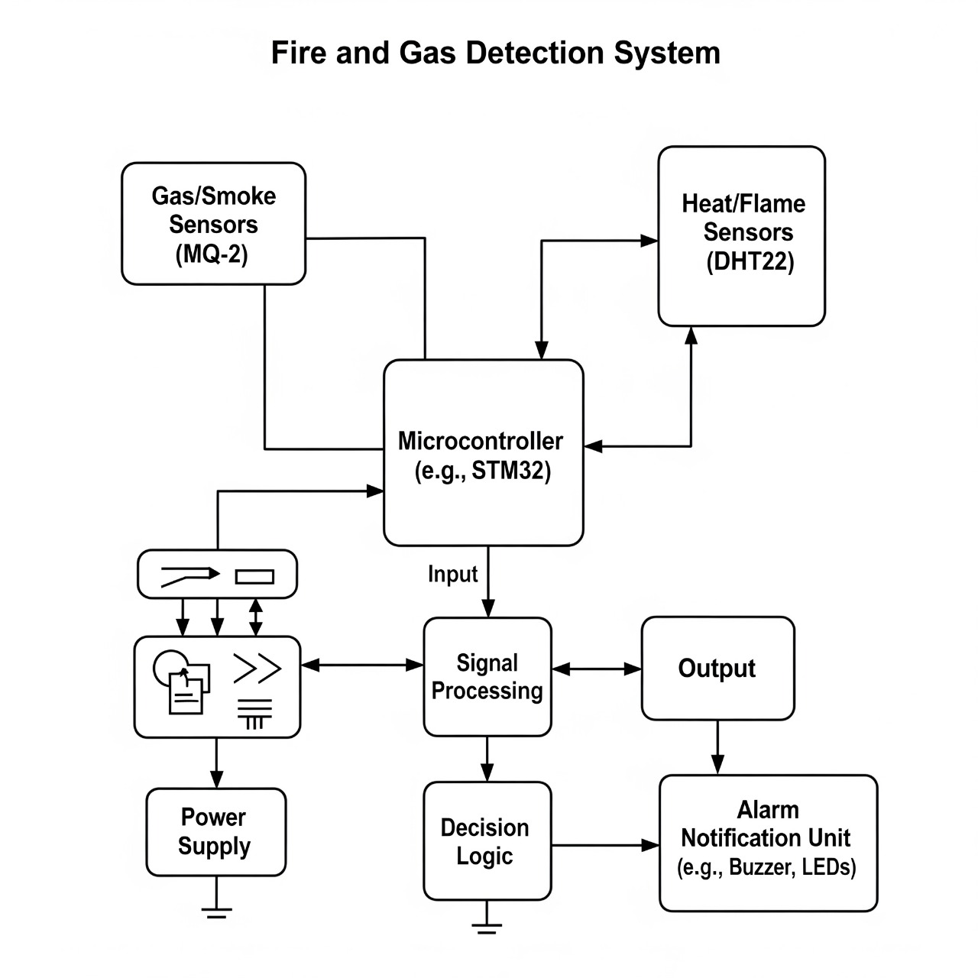

PROGRAM

#include "DHT.h"

#define DHTPIN 16

#define DHTTYPE DHT11

DHT dht(DHTPIN, DHTTYPE);

const int flameSensorPin = 14;

const int buzzerPin = 22;

const int ledPin = 5;

void setup() {

pinMode(flameSensorPin, INPUT);

pinMode(buzzerPin, OUTPUT);

pinMode(ledPin, OUTPUT);

digitalWrite(buzzerPin, LOW);

digitalWrite(ledPin, LOW);

Serial.begin(115200);

dht.begin();

}

void loop() {

int flameState = digitalRead(flameSensorPin);

float t = dht.readTemperature();

float h = dht.readHumidity();

float temperature = dht.computeHeatIndex(t, h, false);

if (isnan(temperature)) {

Serial.println("Failed to read from DHT sensor!");

delay(500);

return;

}

bool fireDetected = false;

if (flameState == LOW) {

fireDetected = true;

}

if (temperature > 40.0) {

fireDetected = true;

}

if (fireDetected) {

Serial.print("FIRE DETECTED! Temp: ");

Serial.println(temperature);

digitalWrite(buzzerPin, HIGH);

digitalWrite(ledPin, HIGH);

} else {

Serial.print("Safe. Temp: ");

Serial.println(temperature);

digitalWrite(buzzerPin, LOW);

digitalWrite(ledPin, LOW);

}

delay(1000);

}